Discernment
December 13th, 2021

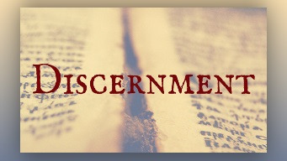
Lord, we will trust You for generous wisdom, discernment and peaceful hearts, all for Your glory. Thank you for protecting our discernment. We praise You for being the decision-making God. It is not our decisions, but Yours that make all the difference. We will plan, but we trust You to order our steps. Amen.

Blessed Mother began speaking to Mother Clare, “I always have something to say Beloved daughter. You are right to direct your prayers to the refugees; this is the most tragic situation along with those being pursued to take mandatory shots. Or shall I say, death shots. Indeed, they were clever to send the shots out in three’s with different substances in them. Two are seriously contaminated and one is saline. That sets people up to question why so many object, they think it is only a theory and begin to despise those who have refused the shots. In this way they accomplish divisions, even in the family. You cannot go anywhere without condemnation being directed at you.

“This was the deliberate end they had in mind to turn families against one another. This was diabolical and intentional to separate people from their support systems. Isolate the sheep so the wolves can close in.

“My people, you cannot trust this government or any government where God has been excluded. Their agenda’s, are, in the long run, Satanic.

“These times are so treacherous that you must stay close to the Lord’s heart to know what is evil and what is good. My children there are no easy ways to remain safe in this climate. And it is only going to intensify. Therefore, I ask you to review all the lessons My Son has given you on discernment. They are listed in the search engine on Heart Dwellers website, and for you my dear children, you must learn this fine art of discerning of spirits. If you do not have it you may ask for it as well, and God who gives all things to you will impart it to you. You cannot navigate without it.

“As more and more demons are released from Nibiru, your discernment will be the deciding factor that guides you safely home. Do not assume that you will be able to tell the true from the false. So much depends on your discernment. You must cultivate this gift if you and your families are to survive.”

